NATIONAL UNIVERSITY OF MODERN LANGUAGE ISLAMABAD
Lab final


Submitted to:
Ms. Fatima Gillani
Submitted by:
Zulqarnain Hassan
Roll No: …………………… SP21379
Subject: …………………… SCD
Department: ……………… BSSE-5-Afternoon
Date: ……………………… 26-12-2024

Task 01
Code;
import java.util.Scanner;

abstract class Shape {
abstract double calculateArea();
}

// Square class
class Square extends Shape {
private double sideLength;

Square(double sideLength) {
this.sideLength = sideLength;
}

@Override
double calculateArea() {
return sideLength * sideLength;
}
}

class Rectangle extends Shape {
private double length;
private double width;

Rectangle(double length, double width) {
this.length = length;
this.width = width;
}

@Override
double calculateArea() {
return length * width;
}
}

// Triangle class
class Triangle extends Shape {
private double baseLength;
private double height;

Triangle(double baseLength, double height) {
this.baseLength = baseLength;
this.height = height;
}

@Override
double calculateArea() {
return 0.5 * baseLength * height;
}
}

class ShapeFactory {
public static Shape createShape(int choice, Scanner scanner) {
switch (choice) {
case 1:
System.out.print("Enter the side length of the square: ");
double side = scanner.nextDouble();
return new Square(side);
case 2:
System.out.print("Enter the length of the rectangle: ");
double length = scanner.nextDouble();
System.out.print("Enter the width of the rectangle: ");
double width = scanner.nextDouble();
return new Rectangle(length, width);
case 3:
System.out.print("Enter the base length of the triangle: ");
double base = scanner.nextDouble();
System.out.print("Enter the height of the triangle: ");
double height = scanner.nextDouble();
return new Triangle(base, height);
default:
System.out.println("Invalid choice. Please select a valid option.");
return null;
}
}
}

public class ShapeAreaCalculator {
public static void main(String[] args) {
Scanner scanner = new Scanner(System.in);

System.out.println("Select a shape to calculate area:");
System.out.println("1. Square");
System.out.println("2. Rectangle");
System.out.println("3. Triangle");

int choice = scanner.nextInt();
Shape shape = ShapeFactory.createShape(choice, scanner);

if (shape != null) {
System.out.println("Area: " + shape.calculateArea());
}

scanner.close();
}
}

Output:
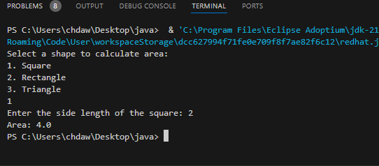
Code Smells in the Program
- Switch Statement for Shape Selection:
  - The use of a switch statement violates the Open-Closed Principle (OCP). Adding a new shape would require modifying the switch block, making the code less extensible.
- Mixed Responsibilities:
  - The main method is overloaded with multiple responsibilities: shape selection, area calculation, and user interaction.
- Magic Numbers:
  - The shape selection menu uses hardcoded numbers (1, 2, 3), which can make the code less intuitive.
- Duplicate Code:
  - Code for user input and area calculation is repeated for each shape.
- Lack of Polymorphism:
  - The design does not leverage object-oriented principles, such as polymorphism, to handle shape-specific behavior

Task 02
Part 1

public class Main {
public static void main(String[] args) {
int a=2;
int b=0;
try {
int divide=a/b;
} catch (ArithmeticException e) {
System.out.println("Arithmetic Exception handled");
}

}
}

Out put:
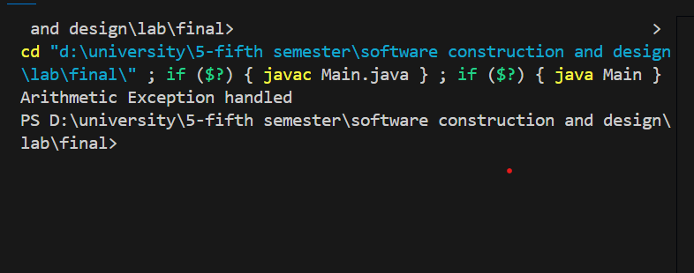

Part 2
import java.util.InputMismatchException;
import java.util.Scanner;

public class Main {
public static void main(String[] args) {
Scanner sc = new Scanner(System.in);
try {
System.out.println("Enter an integer: ");
int integer = sc.nextInt();
System.out.println("You entered: " + integer);
} catch (InputMismatchException e) {
System.out.println("Error: Invalid input. Please enter an integer.");
}

sc.close();
}
}

Output:
